1. **Explain how to use the Canvas and Paint classes to draw shapes in Android.**

Ans:-

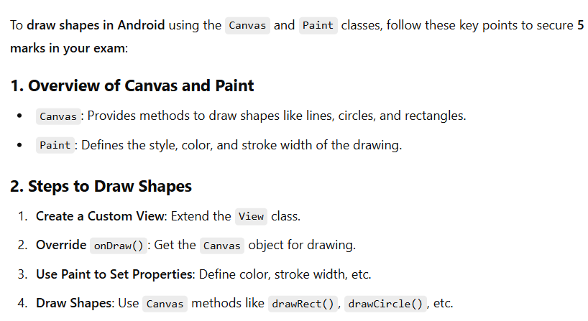

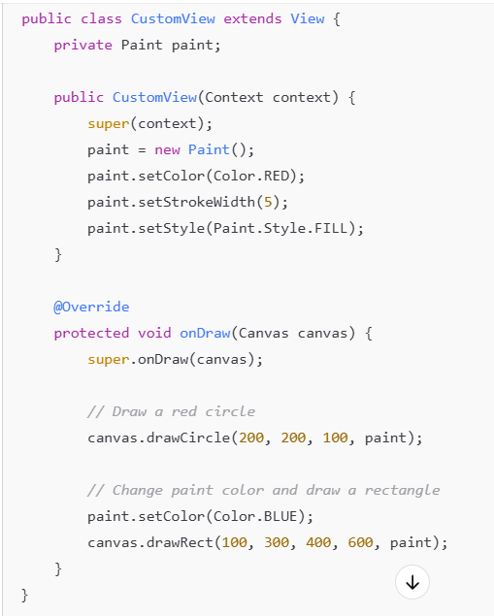

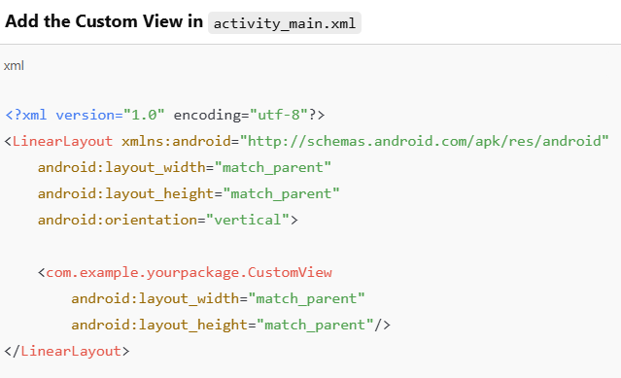

**Apply in activity** :- setcontext(new Customview(this);

**2. Describe the different types of resources in Android and their significance.**

Ans:-

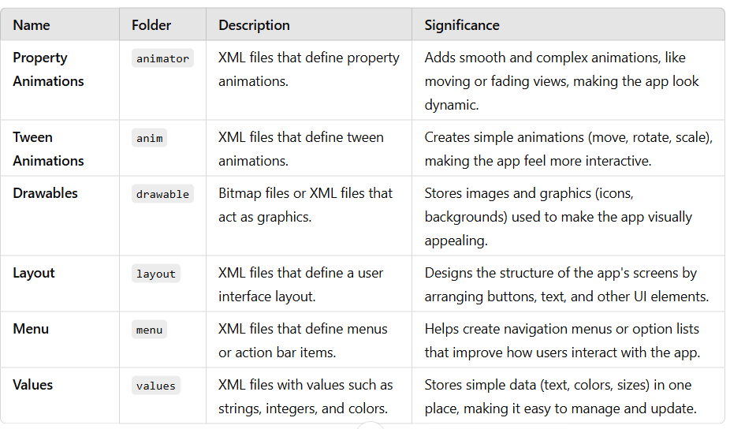

-> **Common Files in the Values Folder**

**colors.xml:** Defines colors (like text and background colors).

**dimens.xml:** Defines sizes (like padding and margins).

**strings.xml:** Stores text used in the app (easy for translation).

**styles.xml:** Defines the overall look (themes, text styles).

**3. What are the different types of animations available in Android? Explain with examples**

Ans:

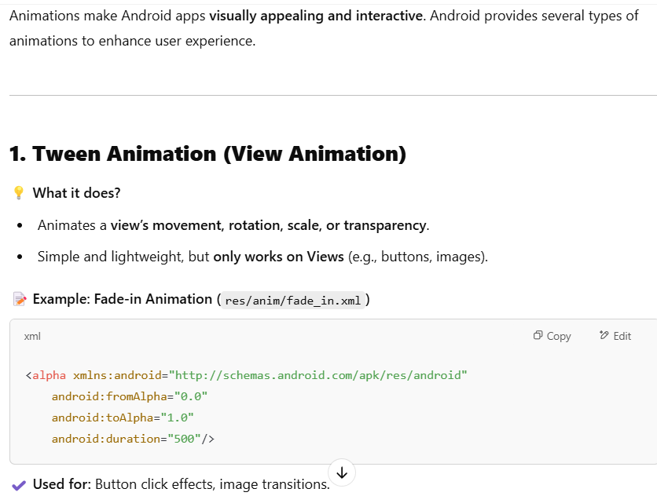

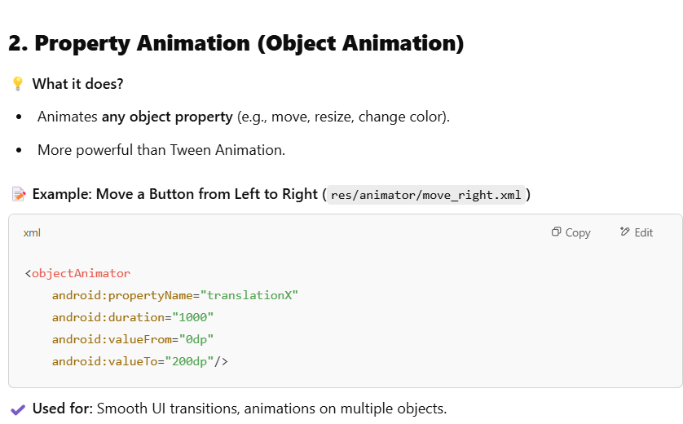

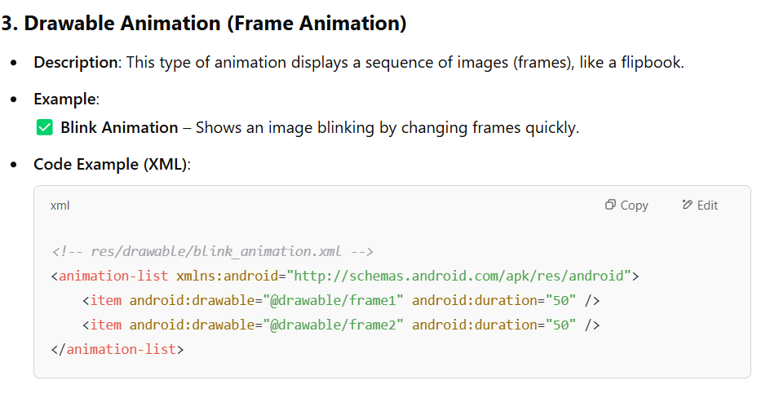

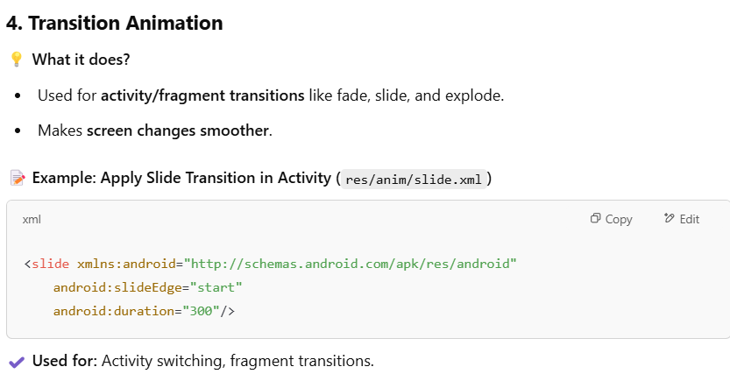

1. **Describe the working of Fade In and Fade Out animations with relevant XML examples.**

Ans:-

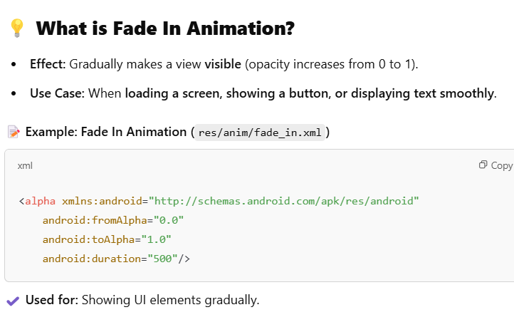

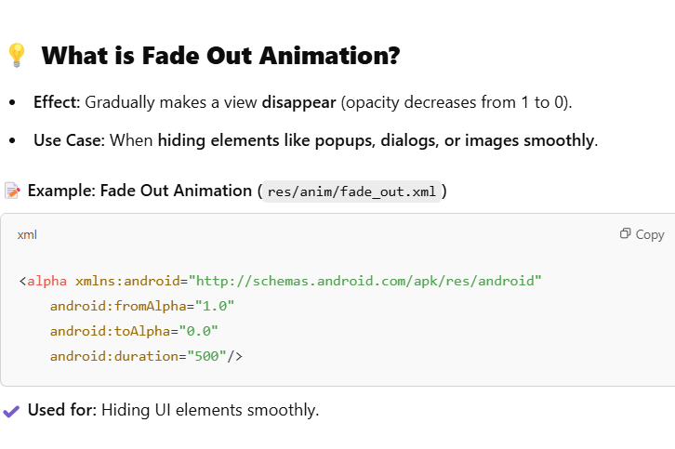

**-> animation apply:-**

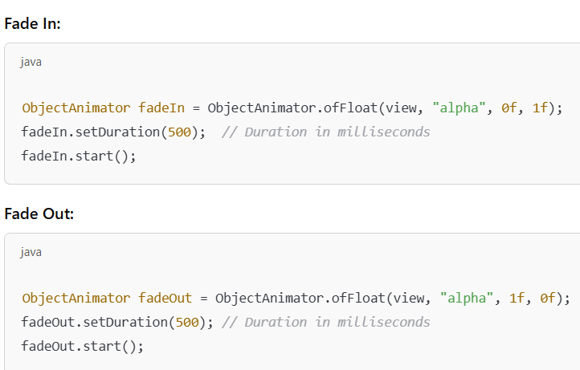

1. **Explain how to apply animations programmatically in an Android application.**

Ans:- 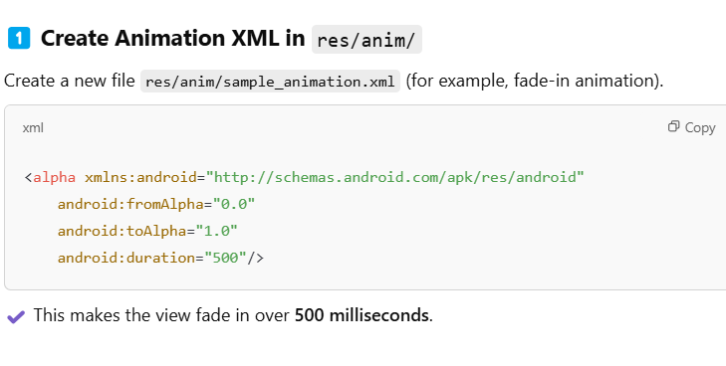

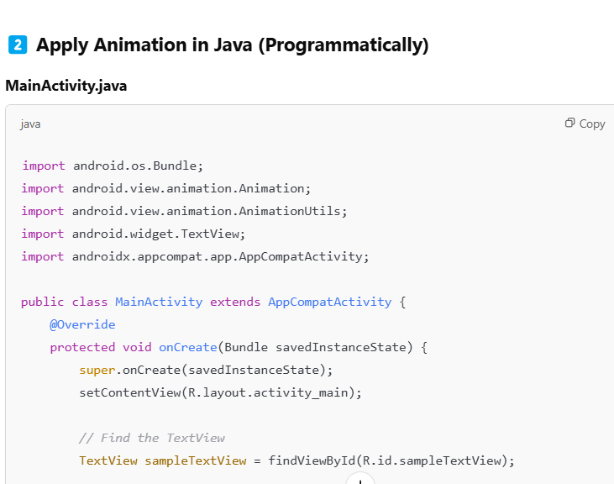

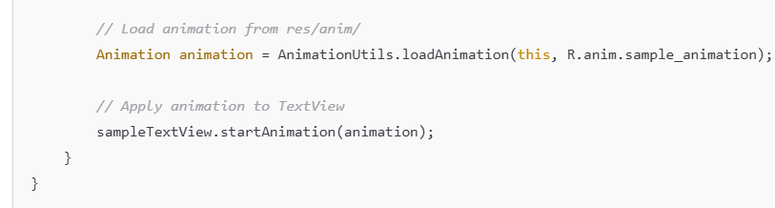

**NOTE: write xml file code your self used in TextView**

1. **Discuss how bitmap images can be drawn using the Canvas API.**

ans:-

* canvas :- the canvas class provides methods to draw on the bitmap**/** surfaceview.
* Bitmap :- the bitmap class represents an image that can be drawn on a canvas.
* paint :- the paint class defines colors, style and effects for drawing

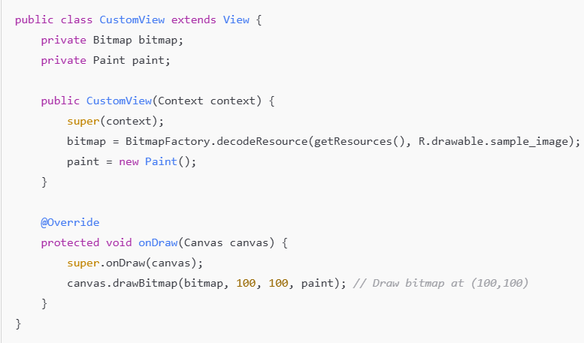

**Apply on program:-**



1. **Explain the various units of measurement available in Android and their significance.**

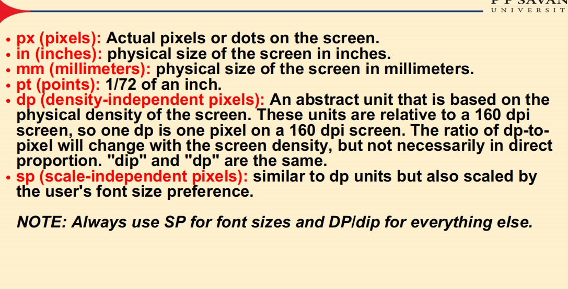

1. **How can animations be loaded from XML and applied to UI components? Explain with an example.**

ans:-

**same answer given in que 5**